Inquiry Performance Task – Index Card Challenge
Ms. Harry
Biology
60 min

Objective: TSW design a scientific investigation applying the steps of the scientific method. (1a, DOK 4)

Materials: index cards, scissors, video, projector, computer

7 min - Bell Ringer + Bell Ringer Review:
Name Date
Bellwork
Write the question and your answer.
After examining a tennis ball and a basketball, Jennifer predicts that if she drops both objects from the top of a building, then the tennis ball will hit the ground first. Which step of the scientific method does this describe?
A. Problem B. Hypothesis C. Conclusion D. Experiment

2 min – Anticipatory Set: Can you fit through an index card? TTW show a brief clip of someone stepping through an index card. Today we are going to use the scientific method to help us develop a plan to fit through a 3X5 index card.

50 min – Procedure:
- TTW walk through an example with the students
- TTW give a sheet of construction paper or white paper to each student
  - Observations: medium size, white, thin, flat, flexible, soft
  - Problem: how can I get a sheet of paper to fly across the room
  - Hypothesis: If I fold it in half and fold the edges down, then it will fly across the room
  - Experiment: fold the paper according to your plan
  - Results: What happened?
  - Conclusions: My hypothesis was (correct or incorrect) because the paper (did or did not) fly across the room
- TTW distribute assignment sheet with attached grading rubric.
- TTW review grading rubric and lab directions with students.
- TTW distribute index cards and scissors (after successfully drawing their plan on index cards)
- TTW assign each student a partner or pair to work with.
- Group 1 (Jeremy, Daisha, Shun) Group 2 (Ricardo, Breonna, Hunter) Group 3 (Jerrico, Deandre)
- TSW complete the index card challenge with their partner/group.
- TSW complete questions in the procedure and post lab questions found on the assignment sheet. If their mission fails, students will devise a new plan and attempt the mission again with a new index card.
- Students who complete the mission successfully will demonstrate with their index card at the front of the room.
- TTW demonstrate how to correctly complete the index card challenge for those who are unsuccessful.
- TTW review post lab questions
- TSW move quickly and quietly back to their correct seats and arrange their desks

3 min – Closure: Today we learned how to design a scientific investigation applying what we have already learned about the scientific method. What was our first step today? Observations. Okay what were our initial observations about the index card? What was our second step? Problem. Okay what was our problem (question) today? What came next? Hypothesis. Next was our what? And what did we do for our experiment. What was the outcome? So what was the final step?

Assessment:
Objective: TSW design a scientific investigation applying the steps of the scientific method. (1a, DOK 4)
Informal: TTW walk around and observe students (M) applying the steps of the scientific method to solve the index card challenge (C).
Formal: TTW assess each student’s ability to apply the steps of the scientific method in an investigation (C) and give each student a score for the index card challenge according to the rubric (M) and the grade will be recorded in gradebook (D).

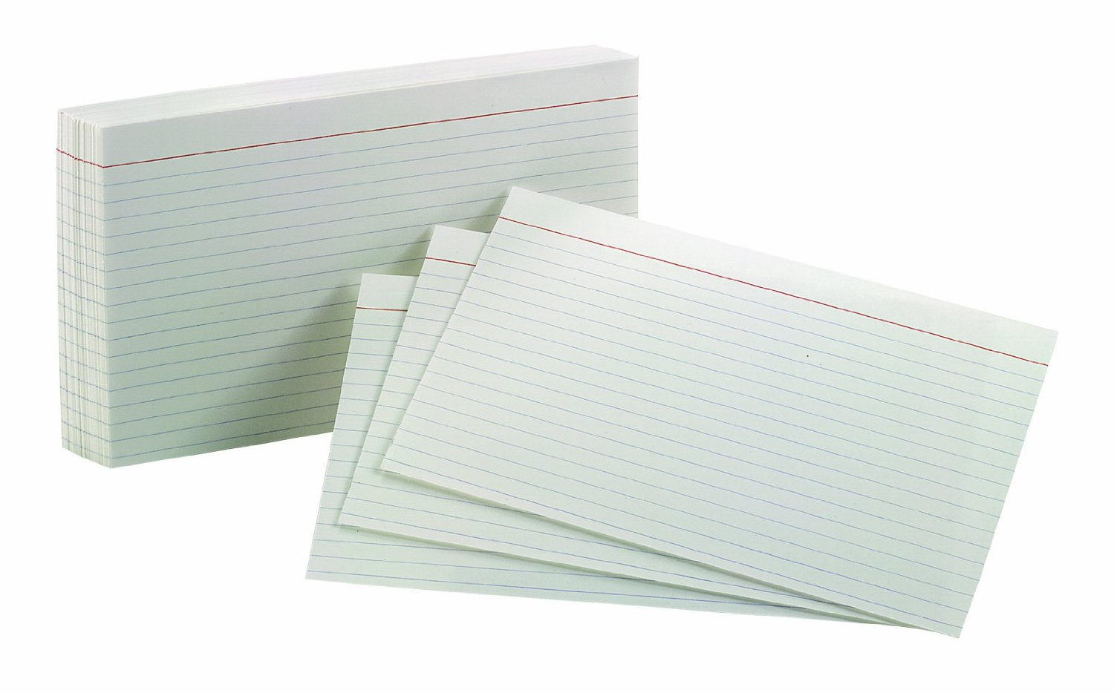
Inquiry - Index Card Challenge

Objective: Think like a scientist! Use the steps of the scientific method to solve a problem.
Directions: You must fit your body (from the top of your head to your feet) through an index card. You can only cut, fold, or tear the index card. NO tape, glue, staples or any other supplies may be used to hold the index card together.
Procedure:
- Examine the index card. What is the shape and size of the card?
- What is the problem (question we are trying to answer)?
- With your partner, brainstorm ways to cut your index card. Draw lines on your index card showing how you will cut it. Write down your plan. RAISE YOUR HAND TO SHOW THE TEACHER YOUR PLAN!
- Test your plan! Cut your index card according to your drawing.
- If you did not succeed with your first card you may use the second card to test your problem again. Follow the procedures step by step.
Post-Lab Questions:
- Apply the steps of the scientific method to your activity. What was your observation, problem, hypothesis, experiment, results, and conclusion?
  - Observations -
  - Problem (question we tried to answer) -
  - Hypothesis (prediction)-
  - Experiment (what did you do)-
  - Results (what happened)-
  - Conclusion (accept or reject hypothesis and why)-
- What did you decide was the best way to complete the mission?
- Why should you always identify the problem before searching for a solution?
- How did testing your problem help you?
- How did sharing your ideas with your classmates help you complete your mission?
- If your mission failed, explain where you think you went wrong.
- If your mission failed the first time, how did you change your plan the second or third time around?

Mission Impossible Grading Rubric

Student Name: _______________________________________________________________________________
