Mitosis and Meiosis Review for Test Stations

Subject: Biology 1 Date: 1/16/2013

Objectives:
- TSW review the learning objectives covering mitosis and meiosis for the review section of Friday’s test (4bDOK2).
Materials:
- Dry erase markers, keynote, review worksheets

Bell Ringer (8 minutes):

Procedures (40 minutes):
- 4 minutes. TTW review procedures and expectations for working in stations and pair students.
- 36 minutes. TSW work in groups of 2-3 to complete the six station review worksheets together without using their notes. After 12 minutes, the students will rotate and the group will begin working on a new set of questions.
Closure:
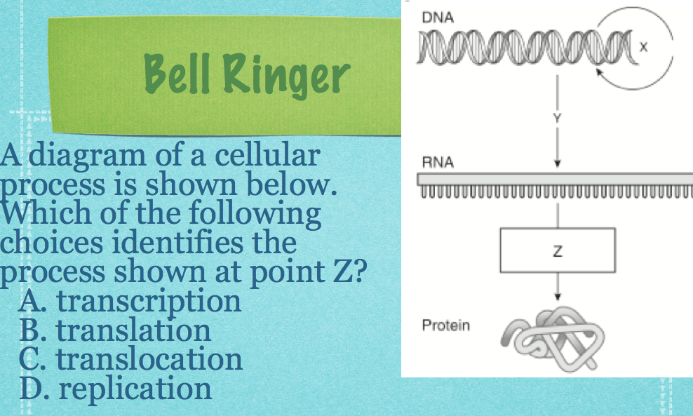
- TTW assess student understanding of mitosis and meiosis by reviewing the questions and answers to the worksheets as a class.
- “Good job today with the review! Remember to study tonight. All of the review questions on the test will be covering mitosis and meiosis.”

Assessment/Evaluation
Objective:
- TSW review the learning objectives covering mitosis and meiosis for the review section of Friday’s test (4bDOK2).
Assessment:
Informal: TTW assess student understanding of mitosis and meiosis learning objectives (C) by having students answer a series of station review questions and TTW walk around during the period observing student work (M).
Formal: A graded test will be given Friday (M) covering the mitosis and meiosis as review (C) and the grade will be recorded in the grade book (D).

